# ECM Library Exchange Server Journaling Interface

Exchange Server 2007, has many changes at the architectural level when compared to Exchange 2003. ECM will only support 2007 so as to avoid always playing catch-up. These changes maximize the features available, one of them being journaling.

As a reminder, journaling is the ability to record all messages flowing in and out of an organization.

It is a very useful feature because there are many legal and regulatory requirements, such as the Sarbanes Oxley Act, SEC Rule 17A-4 and many more, that need a journaling solution.

The journaling method used in Exchange Server 2003 can be used in Exchange Server 2007, but now journaling can be used at the Hub Transport Server role. Due to the characteristic of any message exchanged between users passing through the Hub Transport Server role, new functionality such as journaling mail-enabled contacts, mail-enabled groups, recording user messages with a single journal rule without setting the changes in each mailbox database is provided.

In Exchange Server 2003, journaling took place directly in the mailbox store because there was no hub transport role.

In Exchange Server 2007 we can choose either to have the same option (allowing a Journal mailbox to receive all message traffic from a mailbox database) or to support a number of Mailbox databases. ***We can also create a separate mailbox database to store the mailbox which will receive the journaling. This is the only option ECM Library will support. ECM Library can download a copy of the emails in this exchange folder or it can download and remove the emails in this folder. The latter reducing the chance of running out of storage space on the Exchange Server. Then ,when uploaded in to the repository, the downloaded emails will be removed from the ECM Library Exchange Interface Directory.***

This is the best way as a company’s Exchange Server administrator can set up the “Master Mail Folder”, or whatever they call it and we can download directly from that folder into ECM Library. It is fast, takes about 15 minutes to put it in place and then it just sits on a workstation or server and runs. It is “set it up once” and forget it. All emails throughout the enterprise can be captured and archived before any user sees them. When I say this is the only option we will support, I actually mean, “This is the only option we will support out of the box. Others on an as needed, as negotiated, and an AS PAID basis.”

However, ECM, unlike most, will support going straight after a POP Server or Exchange Server email download. This will not allow a journaling scenario, but will also allow for administrators and certain select users to set ECM such that it does a direct read from the server for individual users. Thus, it bypasses the need for an outlook interface and is by no means confined to going through to capture emails.

# Overview of the Exchange Server 2007 Journal Rule

Exchange Server 2007 uses Hub Transport to journal messages, so it is valid for the whole organization because all the information on Hub transport server is kept and replicated on Active Directory. The process of message journaling has three main components:

* **Journal agent:** This is an agent that can be configured to journal e-mail messages that are sent or received by recipients in an Exchange 2007 organization.
* **Journaling Mailboxes:** This is a mailbox that is only used for collecting journal reports (messages).
* **Journal Reports**: This is the message that Microsoft Exchange generates when a message matches an existent journal rule and then is submitted to the journaling mailbox.

The journaling process is very simple. All the messages that pass through the Hub transport are inspected, and if they match the defined criteria that was configured in the journal rule, a journal report will be created and delivered to the Journaling Mailbox as shown in Figure 07.

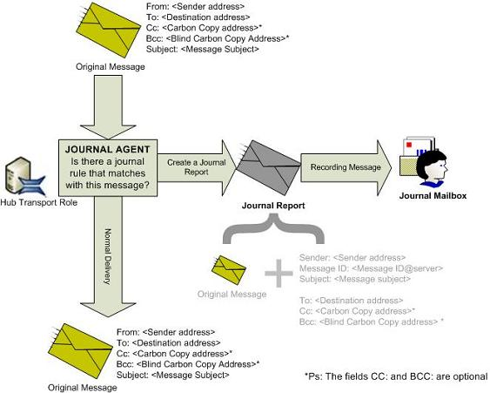  
**Figure 07:** Process of journaling in Exchange Server 2007

**Now... Using the new Exchange Server 2007 feature**

In this section, we will start using the new Exchange Server 2007 feature: the Journaling Rules. Consider the following scenario: we will record all messages sent and received from user **Jose Rodas** in the mailbox **Journal**.

To create a journal rule, follow these steps:

1. Open the **Exchange Management Console**, expand **Organization Configuration**, click **Hub Transport**, and select **New Journaling Rule** on the Toolbox **Actions** (Figure 08).

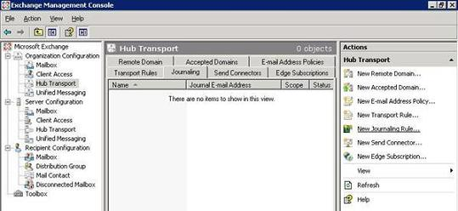  
**Figure 08:** Creating the new journaling rule

1. On the **New Journaling Rule** page, type a name on the **Rule name** field. This name can have up to 245 characters.
2. In the **Journal e-mail address** field, select the recipient that will get all the message traffic for this rule.
3. In **Scope** we can choose one of these options:
   * **Global**: All messages (Internal and External)
   * **External**: Only external messages
   * **Internal**: Only internal messages
4. In the **Journal e-mail for recipient** field select the user who you want a record of his/her messages. For the purpose of our example, we have made a journal rule for all messages sent and received for the user jose@apex07.beta.

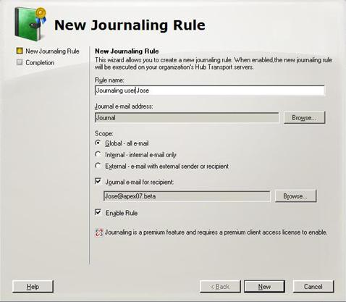  
**Figure 09:** Creating the journal rule

1. On the **Completion** page, the result of the rule creation will appear on the screen with the cmdlet used to create the rule. Click **Finish** to exit (Figure 09).

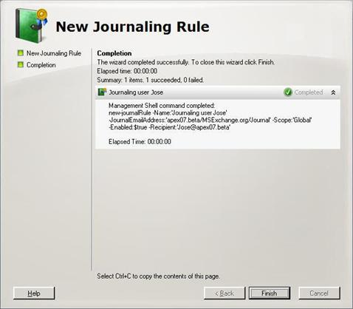  
**Figure 10:** Finishing the rule creation

**Testing the Journaling Rule…**

We will send a test message from the user *Anderson Patricio* to the user *Jose Rodas.* The expected result is to get the message in our recently configured Journal Mailbox (Figure 11).

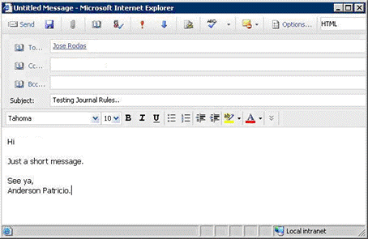  
**Figure 11:** User Anderson Patricio sends a test message to Jose Rodas to test a recently created Journaling Rule

Now, we can access the Journal mailbox and check if the journal rule is working correctly (Figure 12).

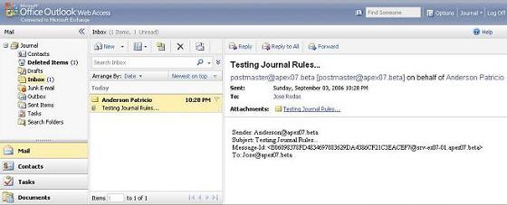  
**Figure 12:** Viewing the message recorded in Microsoft Outlook Web Access

At this point, we see that the journaling rule is working as expected. It was completed with just a rule in the Hub Transport role at Organizational level.

**How can I make a journaling rule for the whole organization?**

In many cases, the journaling feature is required for all the members of an organization because of legal requirements, as we described in the beginning of this article. Using Journaling Rules makes this process easier, storing all the users' messages in the same, or another, mailbox database than the one that actually stores the mailboxes by just creating a rule.

The creation process is just the same, the only difference is that we do not need to choose anything on *Journal e-mail for recipient* so all the organization's mail traffic will be stored in the Journal mailbox (Figure 13).

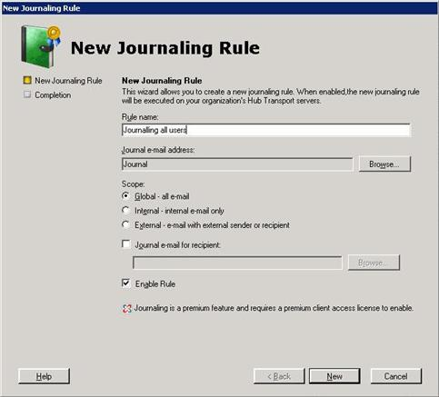  
**Figure 13:** Creating a Journaling Rule for all users

**Problem Resolution: Journaling vs. Transport Rules**

In some cases, we could get a conflict between Transport Rules and Journal Rules.

In order to better understand this difference, we will use the following example. There is a transport rule that blocks all the messages between users Anderson Patricio and Jose Rodas (Ethical Wall), but the administrator is required to record all the messages before they are dropped.

By default, the Transport Agent rules are executed first then Journaling Rules. So, in this situation, it will not be possible to journal when you have a transport rule that deletes some messages. The order of agent transport in Exchange 2007 is shown in the figure below (Figure 14).

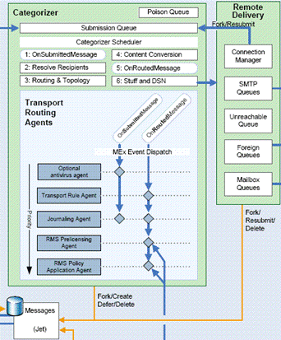

**Figure 14:** Some of Hub Transport Architecture. The full version can be found [here](http://download.microsoft.com/download/f/f/b/ffb96cba-fc3e-476a-a27a-50d63d36d720/Exchange2007_HubTransportRoleArchitecture.pdf) (image courtesy of Microsoft)

So, as stated earlier, the default order does not let us record blocked messages on Transport Rules, so let’s check the order through a cmdlet called **Get-TransportAgent** in the Exchange Management Shell (Figure 15).

To check the orders that are assigned, type the following in an MSH Console:

*Get-TransportAgent*

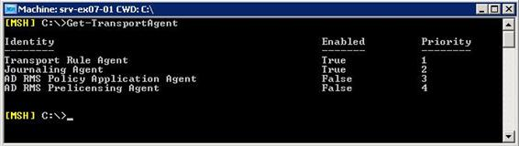  
**Figure 15:** Checking the TransportAgent order priority

In this example, our scenario will not work as expected, in other words, the blocked message will not be recorded in the mailbox Journal.

To solve this, we will have to change the transport agents order with the Set-TransportAgent cmdlet.

The full syntax to solve this is:

*Set-TransportAgent <Transport-Agent-Name> -Priority:<Number> (Figure 16).*

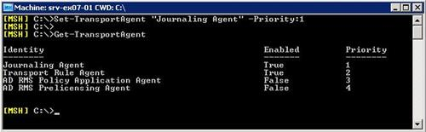  
**Figure 16:** Changing Agents priority and visualizing them after changes

With this change, our scenario works as expected. The Journaling Agent has a higher priority than the Transport Rule Agent. This means that even blocked messages will be recorded in the Journal mailbox. We have it all and there is little chance for something to get by the archive process.

**What this means**

We have discussed how to use journaling’s two different methods:

* The first being similar to Exchange Server 2003 (mailbox database). {not preferred and an extra charge}
* The second, using journaling rules, which is a feature that is available in Exchange Server 2007.

We have also seen that this new method of journaling is easier and more advanced than the method used in previous versions of Exchange Server.

We also determined that using the TransportAgent is much better as orders in the Hub Transport Role of Exchange Server 2007 using cmdlets in the Exchange Management Console. All setup by the corporate administrators and allowing ECM Library top interface in a fast and smooth manner.